**Project Name**: **Magicbookwriter by Powerdrill**

**Project Brief**

A kid's story illustrator using AI. You describe the scene, and it will Illustrate it for you in a kid's storybook style. Uses Stable Diffusion or DALL-E. Basically, you write a story for kids, and the drawing and imagery are generated for you.

**Background**

It’s been proven that stories in pictures and short descriptive texts have become a key factor that helps to develop a child's mind and imagination. This process introduces them to a world full of possibilities. As the world progresses, many people do not have access to create these stories for kids with ease.

**Problem**

While there are several products that one can create books or stories for kids, none makes it possible to do this in the simplest possible way in a very short time. Addressing this problem would be a great opportunity for any parent, teacher, or book writer to create stories in a few minutes that can be read and shown to kids.

**Goals/Benefits**

● Build a feature that automatically generates the images needed in a kid's storybook.

● Enable parents, teachers, and book writers to create stories for kids easily. ● Reduce how long it takes to get a storybook created.

● Allow the user to create an online library of collected stories.

**Key Features**

| Priority | Feature Description |
| --- | --- |
| P1 | Generate Images/illustrations Images/illustrations will be generated using keywords or prompts. |
| P1 | Write a story This is an essential feature that would enable users to write their story in text format |
| P1 | Create a finished Story This would enable users to create a finished page story from the generated  image/illustration and write up (written story) |

**Features to be developed (Roadmap)**

● MVP 1

Generate Images/illustrations

Write a story

Preview and Create story

● MVP 2

Create authentication for users

Build a library folder for previously created stories

Allow users to publish their stories on the platform.

● MVP 3

Collaboration feature for authors

**Success Metrics**

● 70% positive reviews of successfully created stories

● 80% successfully created stories from start to finish

● 15,000 Monthly Subscribers

**Target Market**

Target Users/Customers:

● Story writers who write stories for children between the ages of 2-12. ● Parents who have children between the ages of 2-12.

● Teachers who school kids in **Elementary**, **Middle,** and early stages of **High School.**

**Total Addressable Market (TAM)**

- According to https://worldpopulationreview.com/, the world population is estimated at 7.9 Billion.

- A report from https://www.worldometers.info/world-population/nigeria-population/, estimates Nigeria's population to be 219 Million.

- Estimated number of households

(https://www.helgilibrary.com/indicators/number-of-households/nigeria/) in Nigeria = 43 Million

- Estimated number of households that can pay for the product = 5 Million Proposed cost to access the platform Monthly = $2 Monthly

**TAM (Total Addressable Market)** = (Cost to access the product monthly) x (Estimated Households that can pay for the product) x (12 Months) = $120 Million

**Pricing Strategy**

**Revenue Goal in the First Year**: $360,000

**Strategy to achieve the goal**:

One key success metrics stated was to have 15,000 monthly subscribers in the first year of launch.

From TAM we indicated the cost to access the platform Monthly = $2

**Revenue Goal** = Active monthly subscribers x cost to access the package = 15000 x $2 x 12 Months

= $360,000

**Pricing Strategy**:

• Free access to the platform to create stories..

• Paid Model to access key features such as downloading stories, creating multiple stories, save stories.

**Why this revenue goal:**

The TAM has clearly stated the potential of the market using Nigeria as a case study. This revenue goal is considered based on the worst-case scenario and we believe achieving this is a clear indication that the solution we are offering is valuable.

**Competitors:**

● Storybird.

● MyStorybook.com.

● WriteReader.

● Scribblitt.

● BookBildr.

**Possible Risks**

● **Compliance and Regulations Risk**: Ensure images generated do not go against the general standards.

● **Reputation Risk**: To avoid this, we need to ensure we do everything needed before launch to ensure the product is successful.

● **Demand Risk:** To avoid launching a product with very low or no demand, discussing with the marketing team to ensure the product reaches the right audience is important.

**Proposed Design**

**WireFrame:**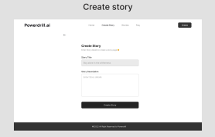

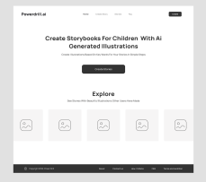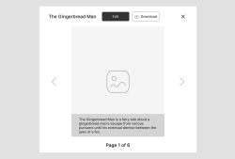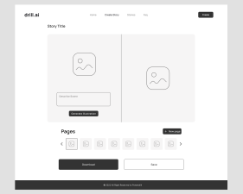

**Hi-Fi Design:**

